PROJECT DESCRIPTION

**Project Overview**

The creation of an app which will be a one-stop platform for offering and booking working spaces. The idea of the app is to go beyond the scope of traditional working spaces and create the possibility for anyone with free conducive spaces to offer them as working spaces on our app. For example; a person can put up a spare room in their home as a co-working space. On the other hand, users, either individual or under a corporate umbrella, can browse these spaces on our app and choose a space for work, meetings, studying, etc.

PURPOSE OF THE PROJECT

**Background**

Congestion in urban cities is a problem that only promises to get worse over the years. Taking Toulouse as a case study where there are currently over 750,000 people in the Toulouse metropole, with an expected growth of 3.36% by 2020, we find that there are only around 20 co-working spaces available offering a total of about 1000 spaces. These statistics shows there is a gap that needs to be filled. With new companies springing up every day or old ones growing bigger and branching out/diversifying, and with the increasing/high cost of rent, we realize that there is a need to find new and innovative ways to house these new ventures both now and especially in the future. The existing co-working spaces are not enough and new entrants in the sector would only be adding to the number of new companies with a lack of where to be housed, especially suitable locations within the metropole and not in the suburbs and within reach of amenities. Hence, we propose this innovative take on co-working spaces.

**Objectives of the Work Next Door (WND) App**

*Decentralize traffic*

A look at Google Maps shows that the peak times for traffic congestion in Toulouse is in the morning between 8 am and 9am and in the evenings between 5pm and 7pm. This can be attributed to the fact that this is the time when most people go to work, drop their children at school and in the evenings around the time most working-class people close from work.

*Increase productivity*

Working at home or in an office means that there is a higher chance of being interrupted as opposed to working in a coffee shop or some other co-working space with less known people. Distractions and interruptions curb productivity and hence, working in an environment where you are less likely to be distracted increases your productivity.

*Better time/schedule management*

In need of a place to work or organize meetings? Having a one-stop platform where you can access, book and pay for a variety of working spaces around you saves you time and helps you plan and manage your schedules and meetings better.

*Generate income from your free spaces*

Many people have free spaces in the homes, offices or other properties which they can offer as working spaces on our app, thus becoming a supplementary source of income.

*Get your product noticed by a wide variety and diverse group of people (product visibility)*

Since the app would be used by people from all works of life, advertisers on our app are promised a wide reach for their products.

*Reduce Pollution/CO2 Emission*

Having working spaces on every corner means that less cars would be on the road driving to dedicated working spaces and hence reducing pollution and CO2 emissions.

SCOPE OF THE APP

**Core Functionalities**

*Searching for a space*

This allows a user to search for spaces in a given location. The user enters a location, searches and is presented with a list of available spaces in that location.

*Viewing a space*

After the user has selected a space, he is taken to another page that displays more details about the chosen space like the distance from the user by various means of transport, available amenities at the space, details about the host, etc.

*Booking and Payment*

If the user is interested in booking the space, he clicks on a button and is directed to a booking page where he can select the type of tariff/plan he wants; daily, weekly or monthly. He is then able to pay by PayPal or bank card.

*Offering a space*

As a host, you can offer a space on the app. You will be required to enter details about the space like price, size, description, amenities and photos.

*Geolocalized meeting suggestion*

Supposing there are 2 or more users that need a location to meet for a meeting or work, they can enter their different locations on the app and the app suggests a meeting location central to all of them. Limited to 4 unique addresses.

*Advertisements*

Businesses or private individuals can decide to put up adverts on our website. This is achieved using Google Ads.

**Scope of the Project**

For the purpose of this project, we have developed only three functionalities of the app;

1. Searching for a space
2. Viewing a space
3. Booking a space.

TECHNICAL SPECIFICATIONS

DESIGN

We considered three different frameworks for the development of the app. Ionic, native Android/IOS and Cordova.

IONIC: An AngularJS based app development framework with material design. Therefore, you have to be knowledgeable in AngularJS to be able to use it, whereas Cordova uses plain JavaScript with the option of including AngularJS. Ionic is based on Cordova but it’s more powerful/complex and with AngularJS.

NATIVE ANDROID/IOS: Cordova is a cross-platform hybrid development platform that allows you to develop Android, IOS and Windows apps from the same code whereas using native app development means developing a different app for each platform.

Since the objective of the project is a mock-up of our app, we decided to use Cordova because it is easy to use and requires only HTML, CSS and JavaScript knowledge

ARCHITECTURE

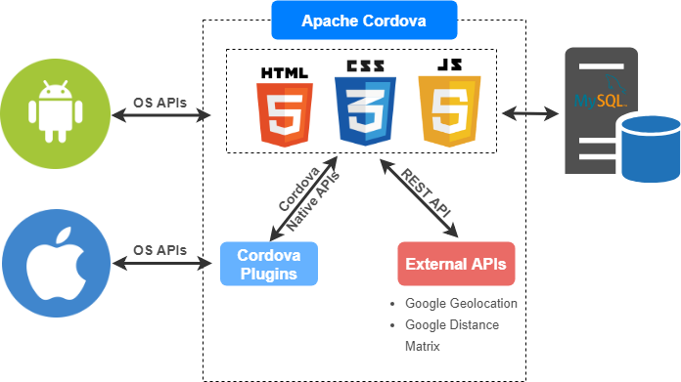

WORKFLOW

**Homepage**

This is the first screen a user sees when he opens the WND app. It contains a search bar where he can search for spaces in a specific location. Underneath the search bar is a “Discover” section that allows a user to browse featured spaces in different cities.

From the homepage, the user can either choose to search for a space in which case he is directed to the search results page, or he clicks on one of the cities available and is directed to spaces available in that city. This is similar to searching for a space but it’s more generalized showing available spaces in the whole city.

**Search Results Page**

When the user searches on the homepage, he is taken to the search results page which consists of a list of spaces around the given location the user inputted on the homepage. The list is ordered by the closest distance to the user.

**Space details Page**

After the user selects a space from the list, he is directed to the space details page where he gets more information about the selected space like pictures, distance by walking, cycling or driving, the host/owner of the space,

